Answers
Task 1
(a) Look at the following table of numbers. Tick each of the numbers that are valid IP addresses.
IP address | Tick if valid IP address
109.194.175.75
723.220.119.49
95.0.256.42
224.115.0.218
78.812.28.132
As each part of the IP address is between 00000000 and 11111111 in binary, the denary equivalent would be 0-255.
(b) Convert each of the valid IP addresses in the table above into their 32-bit binary representation.
109.194.175.75 – 01101101.11000010.10101111.01001011
224.115.217.218 – 11100000.01110011.00000000.11011010
(c) An old PC currently doesn’t have any way of connecting to a home router so that it can connect to the Internet. The user wants to connect to the router using a network cable.
(i) Explain what hardware would need to be fitted to the PC to connect it to the router.
Network Interface card / NIC.
(ii) The user also would like to connect the computer wirelessly to an old local network they created. Is this possible? If so, what hardware would they need?
Yes, it is possible for a computer to connect to more than one network.
They would need to install an additional NIC, in this case it would be a wireless NIC which would contain an antenna.

Task 2
Look at the following diagram of a home network:
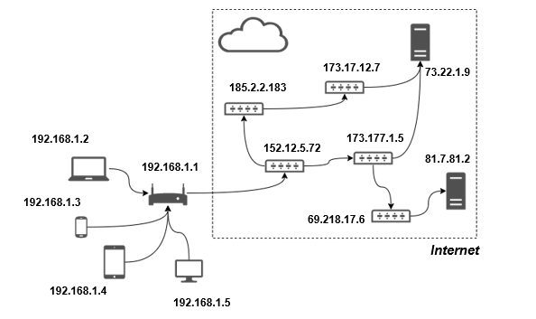
(a) What is the IP address of the home router?
192.168.1.1
(b) What is the IP address of the laptop?
192.168.1.2
(c) State the IP address of one server on the Internet.
73.22.1.9
81.7.81.2
(d) The laptop wants to send data packets to the server with the IP address 73.22.1.9. Give the possible routes that the packets could take.
192.168.1.2
192.168.1.1
152.12.5.72
173.177.1.5
73.22.1.9
192.168.1.2
192.168.1.1
152.12.5.72
185.2.2.183
173.17.12.7
73.22.1.9

